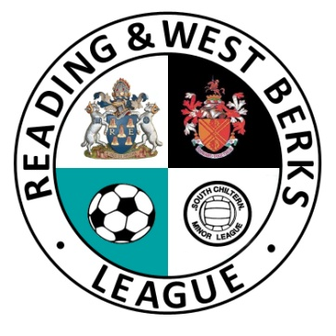
READING & WEST BERKS LEAGUE
WINTER FUTSAL EVENT 2019
MEDICAL EMERGENCY ACTION PLAN (MEAP)

Venue Name: South Reading Leisure Centre
Venue Contact Number: 0118 937 3281
Venue Address: Northumberland Ave, Reading RG2 8DF

FIRST AID FACILITIES AND ESSENTIAL INFORMATION
Nearest Minor Injuries Unit | Royal Berkshire Hospital  21 Craven Road, Reading RG15LE
Nearest Emergency Unit | Royal Berkshire Hospital  21 Craven Road, Reading RG15LE
Nearest Defibrillator | On Site
First Aid Room | On Site

